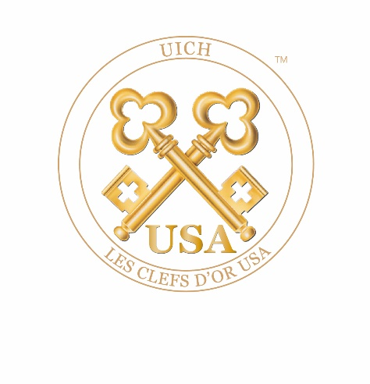

Dear Former Member,

Thank you for your interest in returning to Les Clefs d’Or USA. The requirements for readmission, according to the bylaws, are as follows:

Former members re-entering the concierge profession. If a member in good standing resigns from the concierge profession and re-enters the profession within a three-year time period, the applicant may, immediately upon reemployment as a concierge, submit an application directly to the Board of Directors for consideration of readmission to Les Clefs d’Or USA. If more than three years have passed since the former member resigned from the concierge profession, the applicant must have returned to the concierge profession for a continuous six-month period prior to submitting a request for reapplication to the Board of Directors.

To support this application, you must provide:

☐ A letter of recommendation on company letterhead from your General Manager
☐ A photo of your business card
☐ A photo of your desk showing your concierge sign
☐ A photo of you in your uniform
☐ Human Resource employment verification on company letterhead from your current employer and
☐ Human Resource employment verification on company letterhead from your last employer while working as
a full-time hotel lobby concierge.

Other employment records will not be necessary.

Please Note: The General Manager’s letter of recommendation must be dated within three months of the date on this application. Incomplete applications will be returned and may be cause for rejection of membership in Les Clefs d’Or USA. If you change positions or properties while your reapplication is being processed, you must notify the Director of Membership of your change and forward a new letter of recommendation from your new General Manager to the Director of Membership. Failure to do so will result in the rejection of this application.

Once saved, upload your application via the website and make payment as instructed.

In friendship,

The Board of Directors
Les Clefs d’Or USA
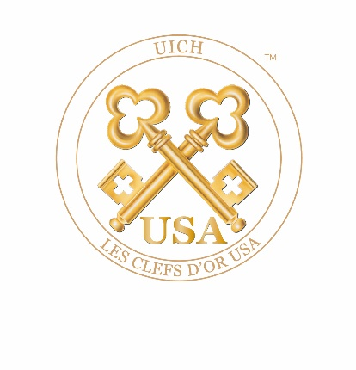

Les Clefs d’Or USA
Application for Readmission

SECTION I: BASIC INFORMATION Date:

Name (last, first, middle initiaI):
Birthdate (month/day/year):
Job Title:
Hotel Name:
Hotel Group or Corporation:
Hotel Street Address:
Hotel City/State/Zip:
Hotel Phone (with area code):
Exact Hotel (nongeneric) Website Address:
Generic Concierge Desk Email:
Personal Private Hotel Email:

Personal Non-Hotel (Private) Email:
Personal Mobile Phone:

Who were your original sponsors:
Sponsor #1:
Sponsor #2:

Home Street Address:
Home City/State/Zip:
Home Phone (with area code):
Date of Birth (Month/Day/Year):
In case of emergency, please contact: Name:
Phone (with area code):
Relationship:

Name and Title of Supervisor:
Number of Rooms in Hotel:
Average Number of Hours Worked Per Week:

Describe in two lines or less the location where you work in the hotel:
List the date you were last a member in good standing:

Have you ever been convicted of a felony? ☐ Yes ☐ No
Does the Concierge Department supervise any other staff? ☐ Yes ☐ No
Are you a member of a local concierge association? ☐ Yes ☐ No
If yes, please state which one and describe your participation:
If no, please explain your reasons:

Are you active in your local concierge community? ☐ Yes ☐ No

Are the local members of Les Clefs d’Or aware that you are applying for membership?
☐ Yes ☐ No
Please describe in two lines or less your reason for answering Yes or No:

The concierges at your hotel are members of what department?
The concierge desk hours of operation are as follows:
Please provide a description of your duties (in two lines or less):
Who handles your duties when you are absent?

Describe the circumstances that led to the ending of your membership:

Describe why you wish to become a member of Les Clefs d’Or USA again:

Describe what you have done since you were last a member of Les Clefs d’Or USA:

SECTION III: ETHIC & PROFESSIONAL STANDARDS

Personal Demeanor
  - Always maintain a professional appearance. Unless told otherwise, wear professional attire to all concierge-related functions.
  - Always use proper grammar.
  - Stay poised and professional under all circumstances; remain polite, courteous and helpful.
  - Honor all commitments to colleagues and others.
  - Never practice nor permit discrimination of any type.
  - Treat colleagues respectfully at all times. Respond to emails and messages in a timely manner (72 hours).
  - Maintain the confidentiality of all member and guest communications.

Guest Relations:
  - Listen attentively to guests’ requests. Always offer to provide guests with written confirmations
of their requests.
- Return all correspondence in a timely manner.
- Always thank guests if they remember you in some way. Send thank-you notes whenever possible.
- Always maintain professional relationships with guests; address guests in a professional manner.
- Tactfully decline illegal or unethical requests from guests.
- Never promise guests results, unless you are positive you can deliver.
- Advise guests, in advance, of surcharges or service fees on tickets or other requests.
- Always provide guests with detailed seat location information, including obstructions, when
acquiring tickets for guests.
- Inform guests of dress codes at restaurants.
- Learn to evaluate guests by their preferences. What might be good for one guest may be unsuitable
for another.
- Always respect and protect the identity and confidentiality of all guests.

Vendor Relations:
- Never double-book restaurants for guests.
- Never accept goods or services from vendors for personal gain.
- A Les Clefs d’Or USA Concierge neither receives commissions from restaurants nor participates in
incentive-driven competitions.
- Always use reputable businesses and service organizations.
- Exercise objective and independent judgment in the evaluation of goods and services.
- Pay all invoices upon receipt.
- Never take advantage of restaurants that invite you for dinner by ordering the most expensive
items on the menu or bringing uninvited guests. Tip your server at least 20% of the estimated bill.
- Remember when you’re invited to theatres, restaurants or other venues, you’re an ambassador of your hotel and of Les Clefs d'Or USA.
- Treat vendors with respect, professionalism and courtesy.
- Always thank your host(s) before you depart and send a note of appreciation afterward.

Social Media:
- Be aware of and abide by your company’s policies when making personal statements about your
company, its subsidiaries and/or any affiliates via any form of electronic media including, but not
limited to Twitter, Facebook, YouTube, Instagram, LinkedIn, etc.
- In the course of your electronic communications, if you receive inquiries from any member of the
press or media regarding Les Clefs d'Or USA, refer the media to the current President or Director
of Media of Les Clefs d’Or USA.
- Do not share information you would not want repeated or photos you would not want publicized.
- Maintain professionalism in your posts. Once you post anything electronically, it becomes public
domain.
- Whether you are on company or personal time, you are not free to share information that is
considered confidential to Les Clefs d’Or USA, including personal guest information or any
company business of your employer.
- Log into the USA and UICH book of members quarterly to keep your profile current.

Public Relations:
- Always speak with your Public Relations Director before speaking to the press. This includes vendor
endorsements.
- In the course of your personal statements or commentary to any media outlet, you may not present yourself as a representative of, or spokesperson for, Les Clefs d’Or USA, unless you have been authorized in writing by the Board of Directors of Les Clefs d’Or USA to do so.
- The use or duplication of the trademarked Bucherer Keys, or the trademarked insignias of Les Clefs d’Or USA or UICH, is prohibited without advanced written consent from the Board of Directors.

SECTION IV: MEDIA RESPONSIBILITY

With the increasing opportunities for exposure and public awareness created by never-ending new trends in e-publishing and social media, it is important to stay on top of Les Clefs d’Or’s policies and procedures (as outlined in our Ethics & Professional Standards).

When using media for personal use and/or as a public relations tool:
- If you receive inquiries from any member of the press or media regarding Les Clefs d'Or USA, refer them to the Director of Media of Les Clefs d'Or USA.
- If you wish to add Les Clefs d'Or USA’s logo or title to your business card (i.e., Member Les Clefs d'Or USA), please submit a request for approval to media@lcdusa.org, along with a copy of the proposed layout.
Our objective is always to promote our good name and positive brand image. We encourage the use of our trademarked insignias by members in order to enhance our reputation. At the same time, we control usage of our logos for two main reasons:
- to avoid confusion on the part of the general public
- to protect our image from inappropriate or unauthorized use

If approved for membership, I agree to submit a media request form (found under the forms tab, on our website) before I’m interviewed or photographed wearing Les Clefs d’Or’s trademarked insignia, crossed golden keys.

Candidate’s Signature: __________________________________________________________________

Your signature above confirms that you understand and agree to uphold the code of ethics, professional standards and media responsibilities of membership in Les Clefs d’Or USA if you are approved for membership.

AGREEMENT

I hereby acknowledge that I have read and agree to adhere to the Ethics & Professional Standards of Les Clefs d’Or USA as outlined on the previous pages.

I hereby authorize Les Clefs d’Or USA or any of its representatives to verify any of my employment references. I also understand that misrepresentation or omission of facts called for, may lead to immediate and permanent expulsion from Les Clefs d’Or USA.

I also hereby acknowledge that, if admitted to Les Clefs d’Or USA, I will abide by the Certificate of Incorporation, the bylaws, and the rules and regulations of the corporation and as they may be amended during the term of this proposed membership. I understand membership is nontransferable and nonrefundable and resides with the individual and not the hotel.

Signature: __________________________________________

Date: __________________________________________

If any of the required documents or signatures is missing, or if any information is inaccurate, your application will be considered invalid and rejected.

If your application is rejected because it is incomplete or contains inaccuracies, you will be required to submit a new application and pay an additional $125 non-refundable application fee if you wish to continue the process.

Please upload this application with requested attachments when complete.

