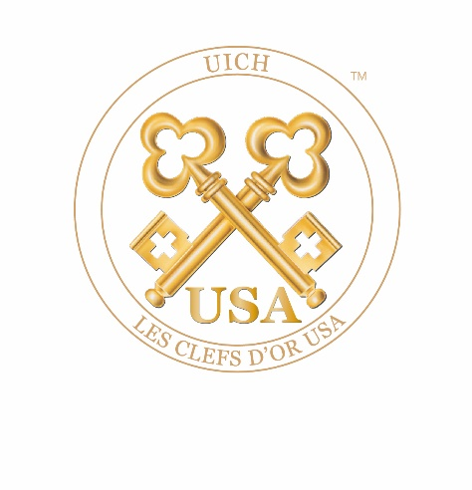

Dear Former Member,

Thank you for your interest in returning to Les Clefs d’Or USA. The requirements for readmission, according to the bylaws, are as follows:

Former members re-entering the concierge profession. If a member in good standing resigns from the concierge profession and re-enters the profession within a three-year time period, the applicant may, immediately upon reemployment as a concierge, submit an application directly to the Board of Directors for consideration of readmission to Les Clefs d’Or USA. If more than three years have passed since the former member resigned from the concierge profession, the applicant must have returned to the concierge profession for a continuous six-month period prior to submitting a request for reapplication to the Board of Directors.

To support this application, you must provide:

☐ A letter of recommendation on company letterhead from your General Manager
☐ A photo of your business card
☐ A photo of your desk showing your concierge sign
☐ A photo of you in your uniform
☐ Human Resource employment verification on company letterhead from your current employer and
☐ Human Resource employment verification on company letterhead from your last employer while working as a full-time hotel lobby concierge.

Other employment records will not be necessary.

Please Note: The General Manager’s letter of recommendation must be dated within three months of the date on this application. Incomplete applications will be returned and may be cause for rejection of membership in Les Clefs d’Or USA. If you change positions or properties while your reapplication is being processed, you must notify the Director of Membership of your change and forward a new letter of recommendation from your new General Manager to the Director of Membership. Failure to do so will result in the rejection of this application.

Once saved, upload your application via the website and make payment as instructed.

In friendship,

The Board of Directors
Les Clefs d’Or USA

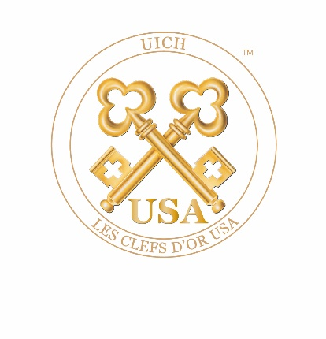

Les Clefs d’Or USA
Application for Readmission

SECTION I: BASIC INFORMATION Date:

Name (last, first, middle initiaI):
Job Title:
Hotel Name:
Hotel Group or Corporation:
Hotel Street Address:
Hotel City/State/Zip:
Hotel Phone (with area code):
Exact Hotel (nongeneric) Website Address:
Generic Concierge Desk Email:
Personal Private Hotel Email:

Personal Non-Hotel (Private) Email:
Personal Mobile Phone:

Who were your original sponsors:
Sponsor #1:
Sponsor #2:

Home Street Address:
Home City/State/Zip:
Home Phone (with area code):
Date of Birth (Month/Day/Year):
In case of emergency, please contact: Name:
Phone (with area code):
Relationship:

Name and Title of Supervisor:
Number of Rooms in Hotel:
Average Number of Hours Worked Per Week:

Describe in two lines or less the location where you work in the hotel:
List the dates you were last a member in good standing:

Have you ever been convicted of a felony? ☐ Yes ☐ No
Does the Concierge Department supervise any other staff? ☐ Yes ☐ No
Are you a member of a local concierge association? ☐ Yes ☐ No

If yes, please state which one and describe your participation:
If no, please explain your reasons:

Are you active in your local concierge community? ☐ Yes ☐ No

Are the local members of Les Clefs d’Or aware that you are applying for membership?
Please describe in two lines or less your reason for answering Yes or No:

The concierges at your hotel are members of what department?
The concierge desk hours of operation are as follows:
Please provide a description of your duties (in two lines or less):
Who handles your duties when you are absent?

Describe the circumstances that led to the ending of your membership:

Describe why you wish to become a member of Les Clefs d’Or USA again:

Describe what you have done since you were last a member of Les Clefs d’Or USA:

SECTION II: ETHIC & PROFESSIONAL STANDARDS

Personal Demeanor
- Always maintain a professional appearance. Unless told otherwise, wear professional attire to all concierge-related functions. Always use proper grammar.
- Stay poised and professional under all circumstances; remain polite, courteous and helpful. Honor all commitments to colleagues and others.
- Never practice nor permit discrimination of any type.
- Treat guests and colleagues respectfully at all times. Respond to emails and messages in a timely manner (72 hours).

Guest Relations
- Respect and protect the identity and confidentiality of all guests.
- Listen attentively to guests’ requests. Always offer to provide guests with written confirmations of their requests.
- Return all correspondence in a timely manner.
- Always thank guests if they remember you in some way. Send thank-you notes whenever possible.
- Always maintain professional relationships with guests; address guests in a professional manner.
- Tactfully decline illegal or unethical requests from guests.
- Never promise guests results unless you are positive you can deliver.
- Advise guests, in advance, of surcharges or service fees on tickets or other requests.
- Always provide guests with detailed seat location information, including obstructions, when acquiring tickets for guests.
- Inform guests of dress codes at restaurants.
- Learn to evaluate guests by their preferences. What might be good for one guest may be unsuitable for another.

Vendor Relations
- Never double-book restaurants for guests.
- Never accept goods or services from vendors for personal gain.
- Do not accept commissions from restaurants or participate in incentive-driven competitions.
- Always use reputable businesses and service organizations.
- Exercise objective and independent judgment in the evaluation of goods and services.
- Pay all invoices promptly upon receipt.
- Never take advantage of restaurants that invite you for dinner by ordering the most expensive items on the menu or bringing uninvited guests. Tip your server at least 20% of the estimated bill.
- When you’re invited to theatres, restaurants or other venues, remember that you’re an ambassador of your hotel and of Les Clefs d'Or.
- Treat vendors with respect, professionalism and courtesy.
- Always thank your host(s) before you depart and send a note of appreciation afterward.

Use of Social Media:
- Be aware of and abide by your hotel company’s policies when making personal statements about your hotel company, its subsidiaries and/or any affiliates via any form of electronic media including, but not limited to Twitter, Facebook, LinkedIn, YouTube, Instagram, etc.
- If you receive inquiries from any member of the press or media regarding Les Clefs d'Or USA, refer the request to the President of Les Clefs d’Or USA.
- Once you post something, it becomes public domain. Do not share information you would not want repeated or photos you would not want publicized. Maintain professionalism in all your posts.
- Whether on company or personal time, never share information that is considered confidential to Les Clefs d’Or USA, including personal guest information or any company business of your employer.
- Log into the UICH book of members quarterly to keep your profile current and active.

Public Relations:
- Always speak with your hotel’s Public Relations Director before speaking to the press. This includes vendor endorsements.
- In the course of your personal statements or commentary to any media outlet, you may not present yourself as a representative of, or spokesperson for, Les Clefs d’Or USA, unless you have been authorized by the Board of Directors to do so.
- The use or duplication of the trademarked Bucherer Keys, or the trademarked insignias of Les Clefs d’Or USA or UICH, is prohibited without advanced written consent from the Board of Directors.

My signature below confirms my commitment to uphold the ethics and bylaws of Les Clefs d’Or USA.

Signature: __________________________________________

Date: __________________________________________

SECTION III: MEDIA RESPONSIBILITY

With the increasing opportunities for exposure and public awareness created by never-ending new trends in e-publishing and social media, it is important to stay on top of Les Clefs d’Or’s policies and procedures.

When using media for personal use and/or as a public relations tool:
- If you receive inquiries from any member of the press or media regarding Les Clefs d'Or USA, you should refer them to the Director of Media of Les Clefs d'Or USA.
- Never share information through your social media communications that you would not want shared or photos you would not want publicized or are inappropriate or unprofessional in any way.
- Whether you are on company or personal time, you are NOT free to share anything that is considered confidential to Les Clefs d’Or USA or your company, including fellow member or personal guest information.
- The use of the trademarked Les Clefs d'Or USA or UICH international logos/insignias for any public relations or marketing usage in your social media communications is prohibited without prior written consent from the Board of Directors to reproduce said trademarks.
- Always speak with your Public Relations Director before speaking to the press. This includes vendor endorsements. In the course of your personal statements or commentary to any media outlet, you may not present yourself as a representative of or spokesperson for Les Clefs d’Or USA unless you have been authorized in writing by the Board of Directors to do so.
- If you wish to add Les Clefs d'Or USA’s logo or title to your business card (i.e., Member, Les Clefs d'Or USA), each company/hotel decides what is included. If you intend to use the logo, please submit a request for approval to media@lcdusa.org, along with a copy of the proposed layout..

Our objective is always to promote our good name and positive brand image. We encourage the use of our trademarked insignias by members in order to enhance our reputation. At the same time, we control usage of our logos for two main reasons:
- to avoid confusion on the part of the general public
- to protect our image from inappropriate or unauthorized use

Please download and submit a separate media request form for each incident or use (including news, entertainment, education, data or promotional messages) where information is printed and/or disseminated.

Candidate’s Signature: __________________________________________________________________

Sponsor #1 Signature: __________________________________________________________________

Sponsor #2 Signature: __________________________________________________________________

Your signatures above confirms that you understand and agree to uphold the media responsibilities of membership in Les Clefs d’Or USA if you are approved for provisional membership.

SECTION IV: SIGNATURE

I hereby acknowledge that I have read and agree to adhere to the Ethics & Professional Standards of Les Clefs d’Or USA as outlined on the previous pages.

I hereby authorize Les Clefs d’Or USA or any of its representatives to verify any of my employment references. I also understand that misrepresentation or omission of facts called for, may lead to immediate and permanent expulsion from Les Clefs d’Or USA.

I also hereby acknowledge that, if admitted to Les Clefs d’Or USA, I will abide by the Certificate of Incorporation, the bylaws, and the rules and regulations of the corporation and as they may be amended during the term of this proposed membership. I understand membership is nontransferable and nonrefundable and resides with the individual and not the hotel.

Signature: __________________________________________

Date: __________________________________________

If any of the required documents or signatures is missing, or if any information is inaccurate, your application will be considered invalid and rejected.

If your application is rejected because it is incomplete or contains inaccuracies, you will be required to submit a new application and pay an additional $125 non-refundable application fee if you wish to continue the process.

